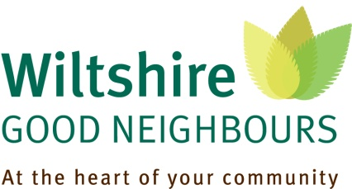

Wiltshire Good Neighbours (WGN) is a new scheme designed to connect older and vulnerable residents of rural communities with services that can promote independent living and well-being. Good Neighbour Co-ordinators, who live locally, provide information and act as a bridge between those who need assistance and the support services provided by statutory bodies and voluntary groups. These services include
- Transport – for shopping and health related visits
- Home security, safety, maintenance and repair
- Befriending and social networks
- Financial advice
There is now a Co-ordinator for the Deverills, Crockerton, Sutton Veny, Heytesbury, Boyton, Bishopstrow, Upton Lovell, Codford and Sherrington; so, if you would like to talk about issues of concern , or need information about the support that may be available to older residents, please contact Andrea Llewellyn 07557 922033 or e-mail: gncarea24@communityfirst.org.uk
Wiltshire Good Neighbours is a free and confidential service provided through a partnership of Wiltshire Council, Community First, Wiltshire Age UK and Age UK Salisbury District.

